Problem: How can we set up progress notes after a 1-hour session has been completed to also show a separate 10-minute progress note that will accompany it to show up as a connected group of notes in a data query report?

Solution: Part #1 – Create matching session type codes. One with the description of the 1-hour session. The other with a description of 10-minute documentation.

In this example, I have created two matching sets of type codes for one Billable note I have a corresponding Documentation note. For every billable note that requires matching documentation create system type code (for example) with 800 series numbers or any series of numbers not being used in Session Type. This will make it easy to find when the user looks up the needed session type to record.
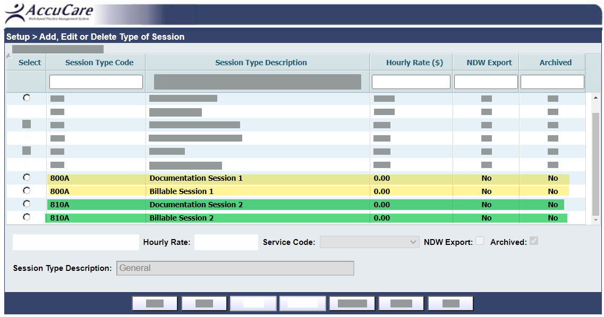

Solution: Part #2 – Use Progress Notes to record a billable note and a documentation note for each client who has completed respectively 1-hour session with a 10-minute note.

In these examples, you can see I have created a pair of matching progress notes for each client
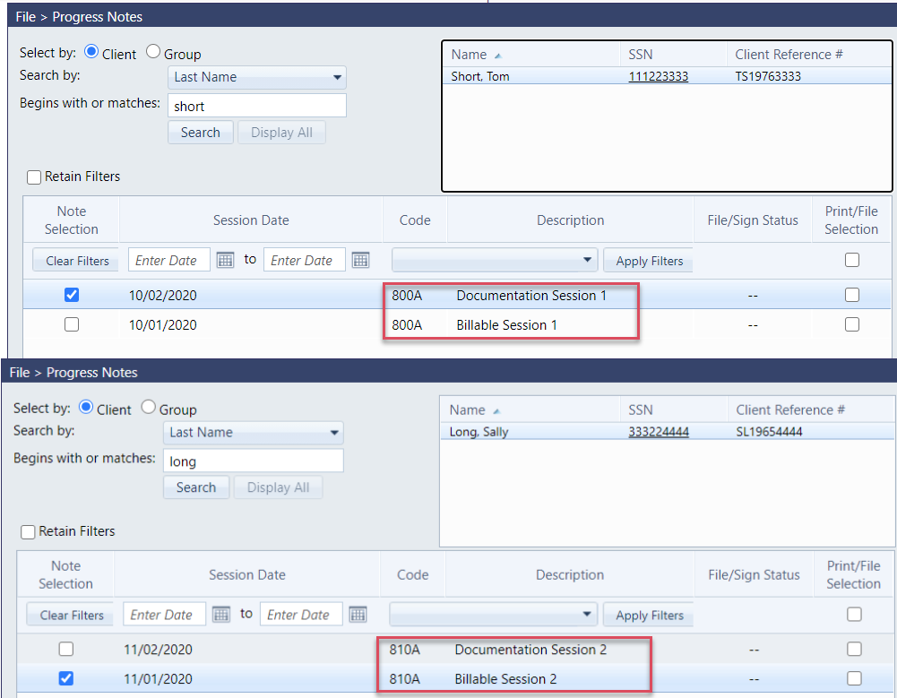

Here, a user would be presented when to record a billable service with a matching documentation Session Type.
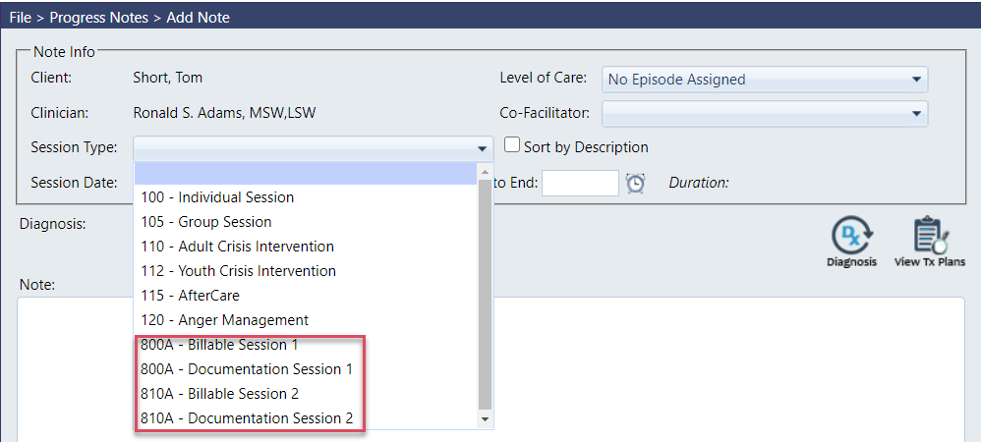

Solution: Part #3 – Super Admin or Admin would run the following Query parameters to create a list for Billers to review billing actions:
Open Data Query
1) Select Progress Notes
2) All Questionnaires
3) Create a New Query
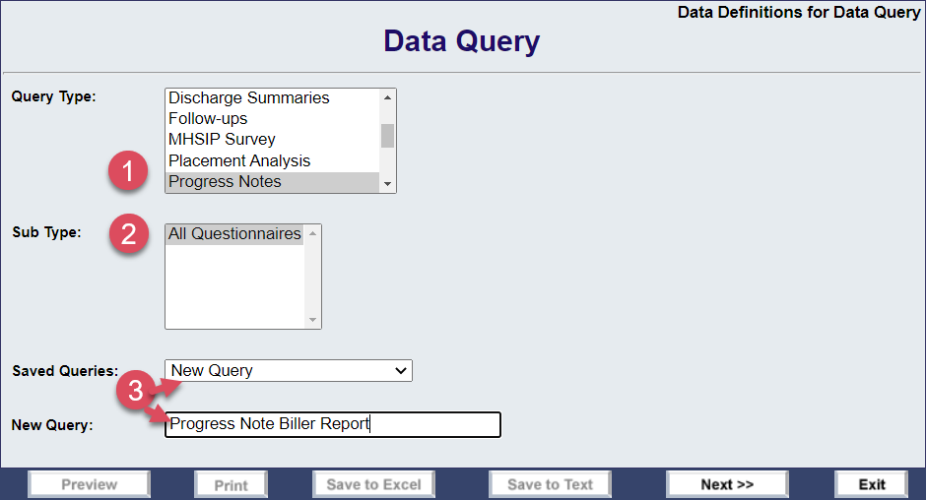
Next Screen
1) Highlight a data filename from the Available list
2) Click the [Select] button to add
3) Here is a list and the order of the data files to pull for this report
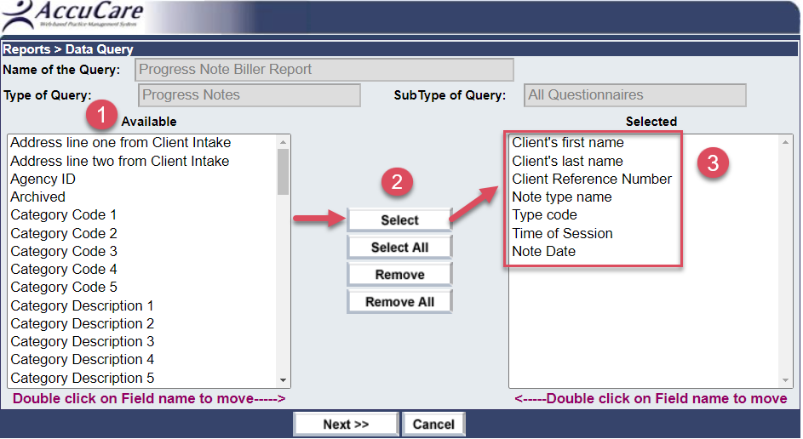

Last Screen (before running the report)
Set Criteria
a) Select Note Date – Beginning Date
b) Select Note Date – Ending Date
c) Select Type Code – Begins or match code of session Type you wish to focus the report output on
Set Sort Order
d) Sort Order 1 – Client last name / Ascending
e) Sort Order 2 – Note type name / Ascending
f) Sort Order 3 – Type code / Ascending
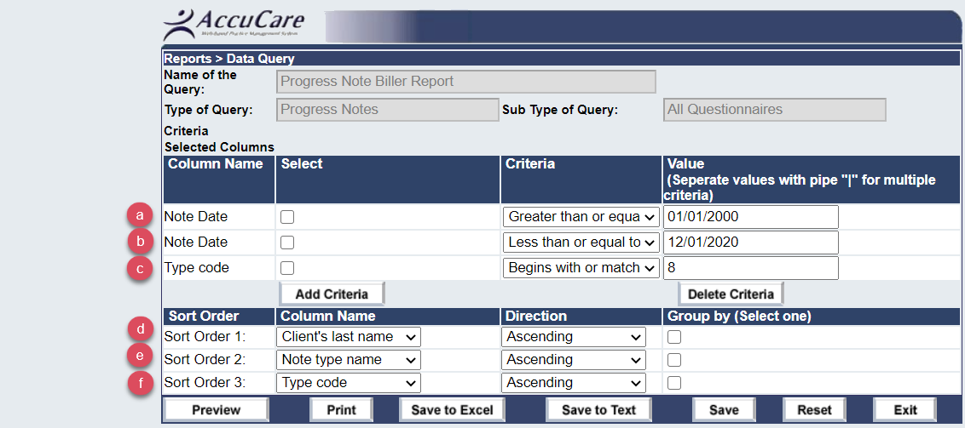

Output view – Preview
