**Super Admin Guide**

**Create Picklists for Gender, Race Ethnicity, and Language**

As the Super Admin, you can expand the gender, race, ethnicity, and language of picklists found in the demographic form.

1. 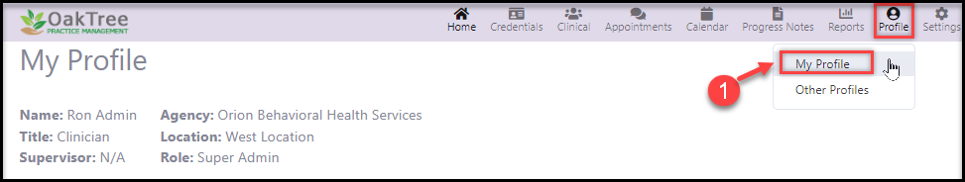**To Start: Go to the Profile icon found in the top right menu bar. Select My Profile.**
2. 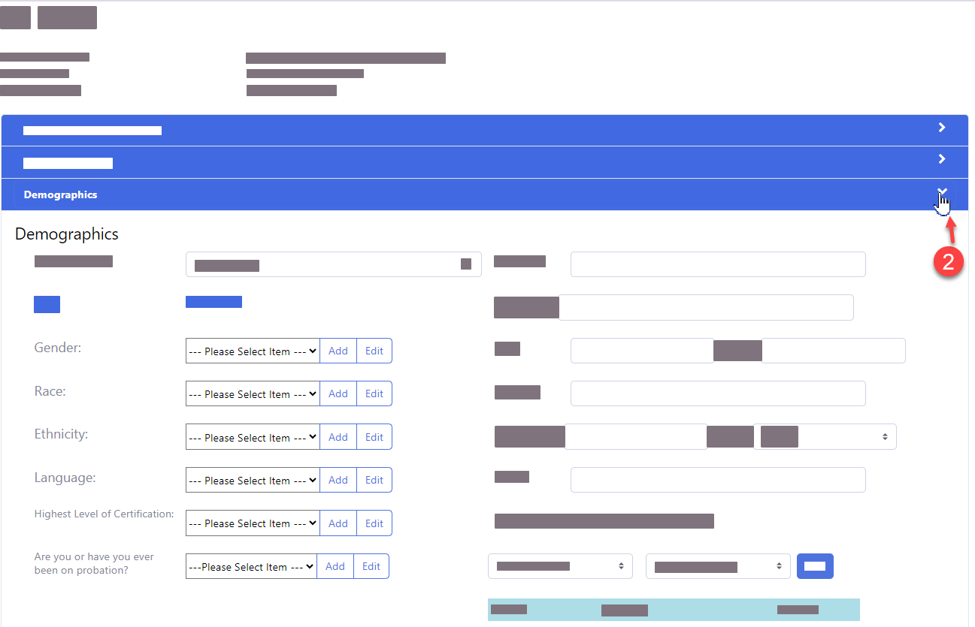**Click the Demographic Menu to expand it**
3. **Go to Gender - click the dropdown to see the default list**

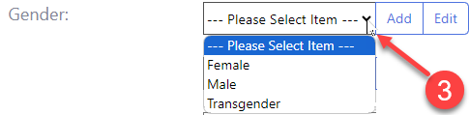

1. **Use the [Add] button to create additional items for the picklist.**

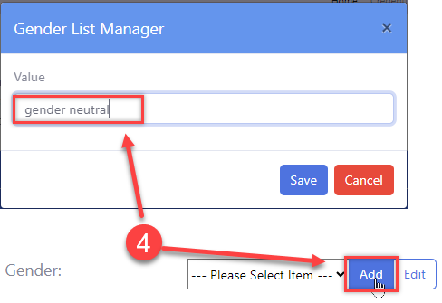

1. **Repeat steps 3 and 4 to create a picklist for Race, Ethnicity, and Language.**
2. **You can also add the picklists for the Highest Level of Certification, if applicable.**
3. **Click the button to save all changes.**

**For additional questions, contact AccuCare Support at 800-324-7966 or email support@orionhealthcare.com and we will be happy to assist you!**