**OakTree Practice Management:**

**Navigating the Calendar**

The OakTree Calendar enables you to create appointments for your clients and staff. In this guide, we show you how to navigate the calendar and show you the functions of the available buttons.

**Navigating the OakTree Calendar**

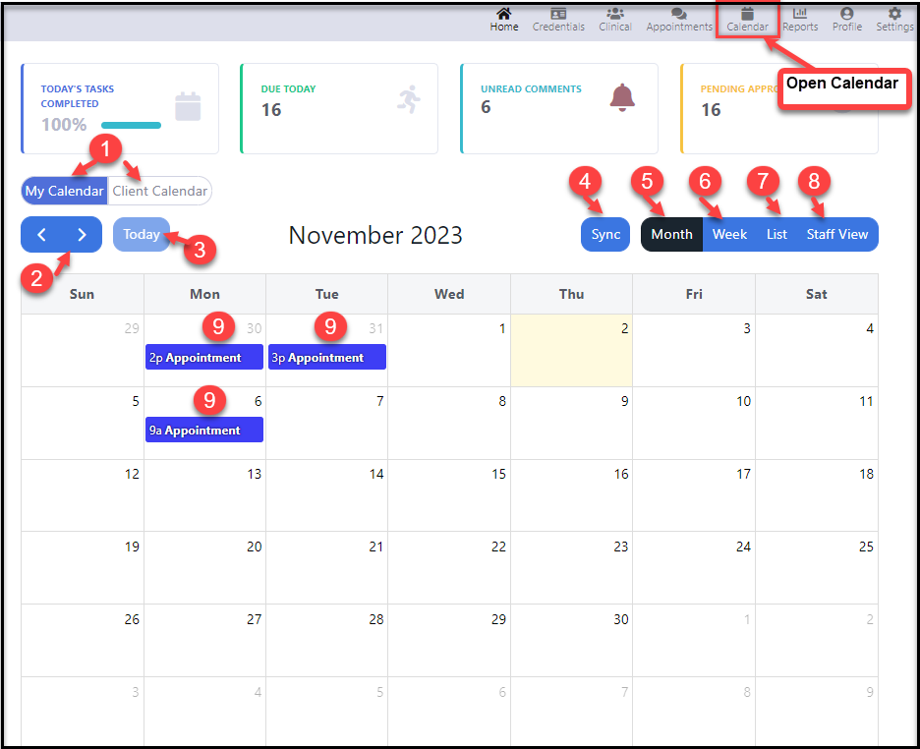Located on the Menu click the {**Calendar**} Icon to view your calendar

**Button Overview**

1. **My Calendar/Client Calendar button** – You can toggle between your calendar which is the default view and your client’s calendar view
2. **The Navigation button** – The arrows allow you to move forward or backward by a month, week, list, or staff view.
3. **Today button** – Use the button to return today’s date
4. **Sync button** – Sync to Connect Outlook or Copy the Calendar link
5. **Month View** – Switches to month view
6. **Week View** – Switches to week view showing one week at a time
7. **List View** – Switches to list view showing any appointments for the chosen week
8. **Staff View** – View other staff calendars (With security access. See user setup below)
9. **Appointments** – Hover your mouse pointer to see a list of invitees or double-click to see details

**Manage Users/User Setup**

For a user to access calendars for all other users, they must have the “Access to All User Calendars” radio button set to “Yes”

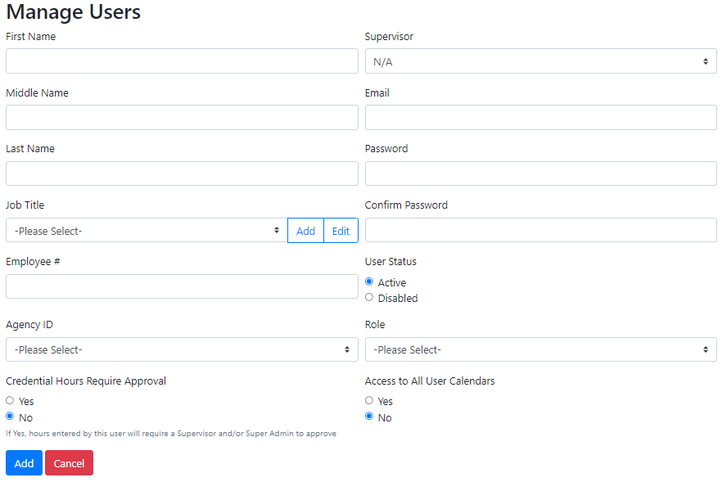



**[My Calendar/Client Calendar] buttons**

Use the [Client Calendar] button to pull up your client schedules

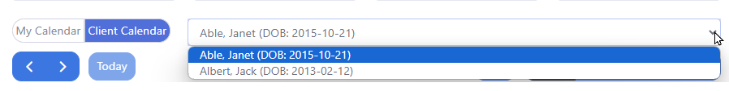

**[Sync] button**

The Sync option provides a way to synchronize to your Outlook calendar. When you click the [Sync] button you will be instructed to either connect to Outlook or copy a calendar link.

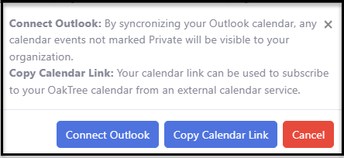

**[Month] button**

The monthly view will show your appointments which you can hover over to the list of invitees. To update the appointment just double-click the appointment.

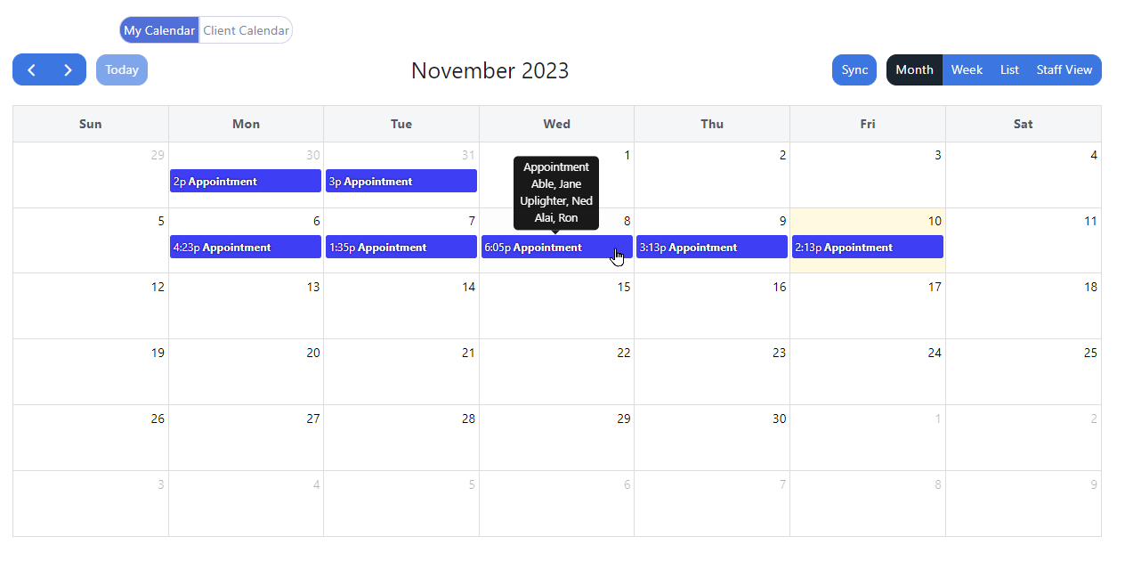

**[Week] button**

For a closer view of your appointments use the weekly view. You will also be able to double-click the appointment here to modify your appointments. For appointments that are linked to, you can view (but not edit)

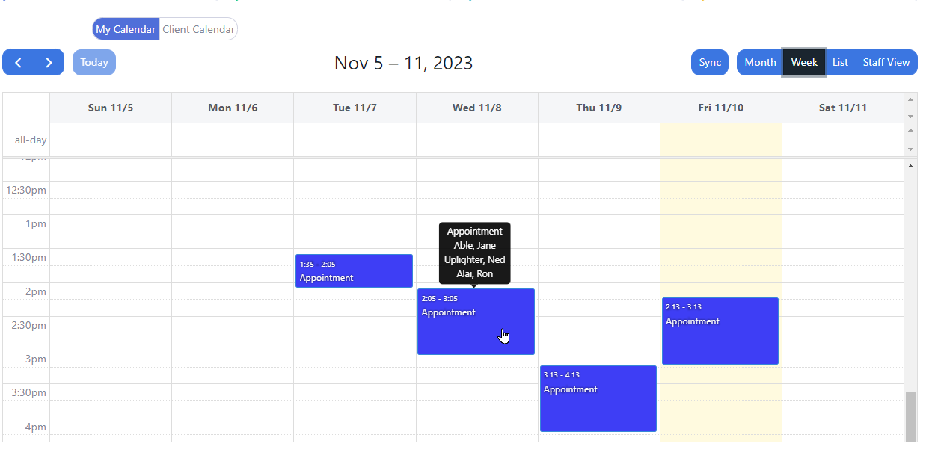

**[List] button**

The List provides a list by week of all your appointments both in-person and video conference. You will also see a [Join Now] button for appointments that are video conference meetings. Each [Join Now] button has a unique meeting ID.

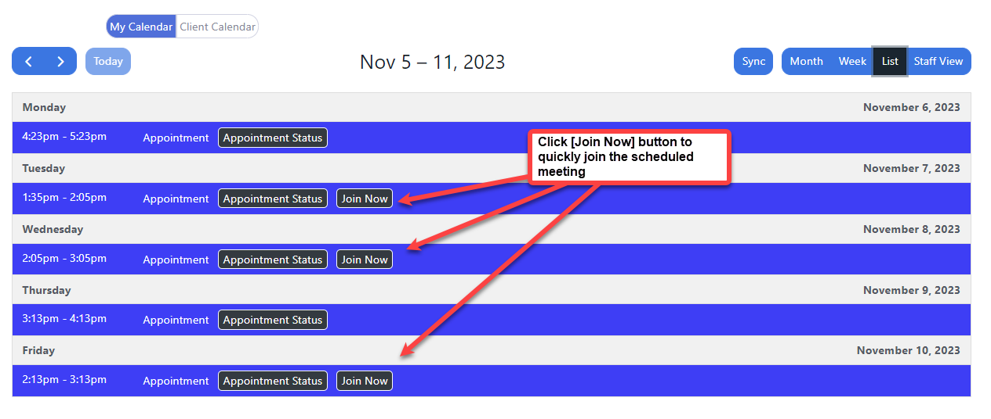

**[Staff View] button**

The Staff View button is available for users who are granted access to all calendars. Users can select one or multiple users to view their appointments.

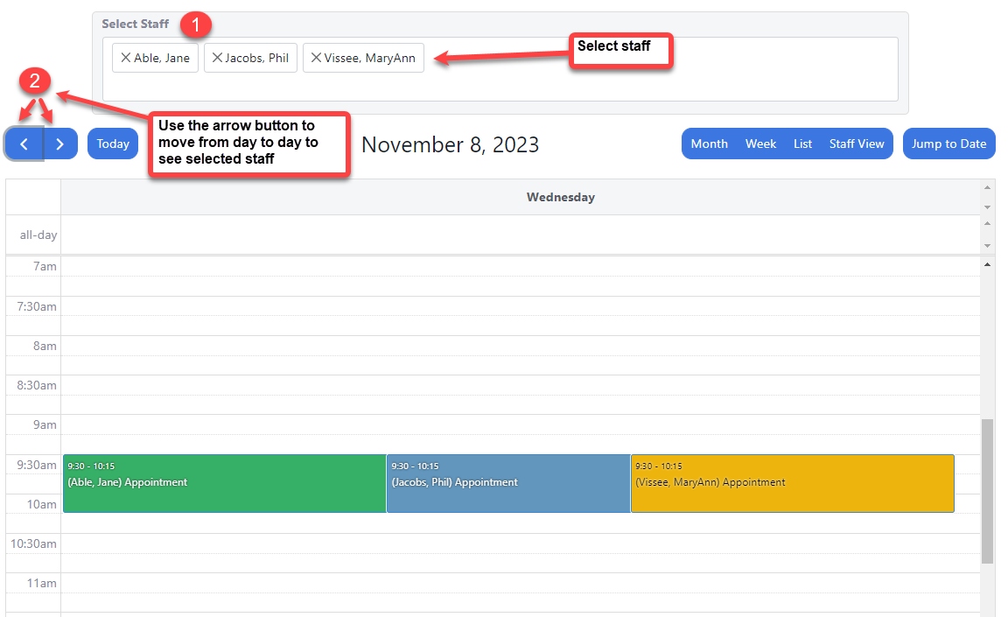

**[Jump to Date] button**

Users with access to the Staff View will also have access to the [**Jump to Date**] button. This feature allows users to move quickly to a specific date on the calendar.

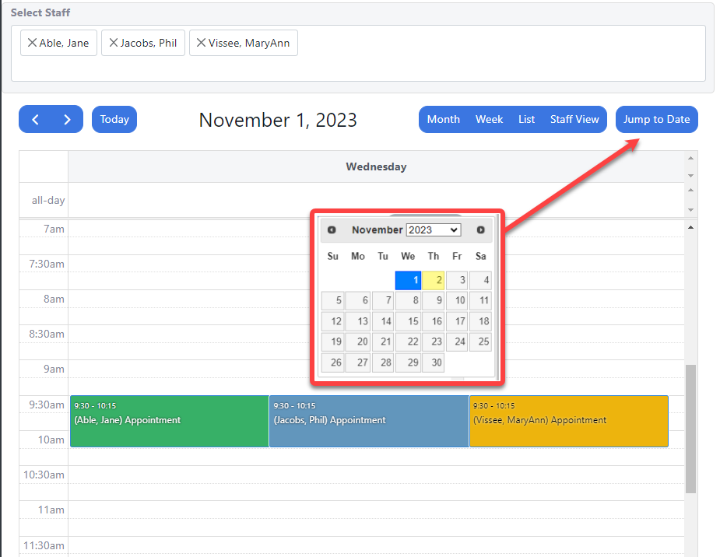

**For more questions, user guides, and tutorials on OakTree, visit our 24-hour online** [**Help Center**](https://orionhealthcare.zendesk.com/hc/en-us?extra-level=2)**, call us at 800-324-7966 or email** [**support@orionhealthcare.com**](mailto:support@orionhealthcare.com)